Sophia Ghoneim
13686402
Niall Martin
Moving Images in Film and Literature
21/12/2023 The Invisibility Cloak:
A “New Weapon” Against Societies of Control?
In the case of capturing one’s image through photography, the one who takes the picture is not only hidden outside the frame of the image captured but is also shielded behind the lens of the camera. In the case of societies of control, however, this practical explanation of how the gaze benefits from seeing without being seen is complicated by the immateriality of modern systems. The “Invisibility Cloak,” a study, product, and tool of resistance developed by Computer Science students from the University of Maryland is a sweatshirt that offers invisibility from AI surveillance cameras through the use of “adversarial patterns” (Computer Science University of Maryland, 2020). In this sense, the Invisibility Cloak makes the invisible gaze of the camera visible by materializing the virtual code that AI uses. Moreover, the object showcases that not being seen by becoming an image is a not only a tool of resistance but also a commodity and a service.

The Invisibility Cloak showcases that the shift from a disciplinary to a society of control involves an immaterial and less easily detectable gaze of surveillance. In Foucault’s theory, the prison guard is at the center of the panopticon, readily visible as an authority and power figure. Whereas, in a controlled society, as Deleuze puts it in “Postscript on the Societies of Control” (1992), “ultra-rapid modes of free-floating control” have “replaced the old disciplines” (4). With AI surveillance systems, the authority figure been decentered, dispersed, and incorporated; the camera in the corner has replaced the guard in the center. Not only that but there is no one behind the camera, no one to point a finger to. The circulation and marketing of the Invisibility Cloak act as a way of propagating knowledge and awareness of how these modern systems of surveillance work. As the website explains, “detectors work by considering thousands of ‘priors’ (potential bounding boxes) within the image with different locations, sizes, and aspect ratios” (Computer Science University of Maryland, 2020). In this sense, the object makes visible the invisible code behind modern systems of control by materializing its way of seeing; showcasing that AI surveillance systems “see through the forms of power that they are designed to enhance and to reproduce” (221), or as the website puts it, ‘priors.’
Moreover, the Invisibility Cloak resists modern surveillance by “becoming an image” (Hito, 0:4:34), giving way to a new, hybrid mode of mobility. Just like Hito Steyerl’s “How Not to Be Seen” (2013), the sweatshirt explicitly uses invisibility as a tool of resistance. The cloak is described by the website as an “adversarial attack” made to “fool an object detector, “by training patterns that suppress the objectness scores produced by a range of commonly used detectors, and ensembles of detectors” (Computer Science University of Maryland, 2020).
Figure 1: Invisibility Cloak with Adversarial Pattern
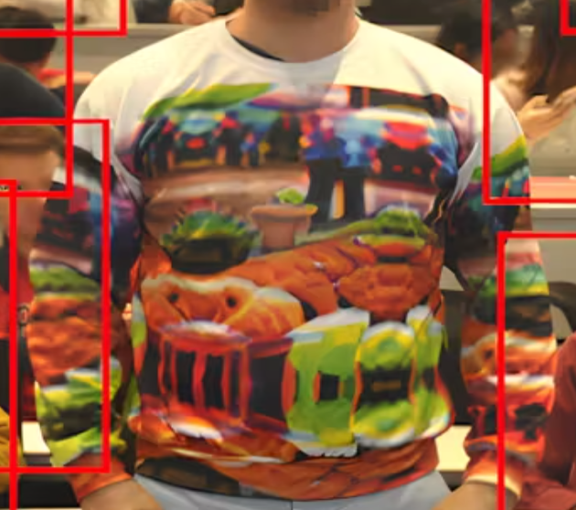
In other words, the object takes up the code used by AI and allows “the body to become itself a medium of transmission, rather than a transmitted content” (qtd. in Ashton, 103), by using the system’s way of perceiving against it. Unlike Steyerl’s ways of not being seen, however, the way in which the wearer becomes an image through the Invisibility Cloak works both in the “physical world” and the virtual (Computer Science University of Maryland, 2020). Whereas painting one’s face would be perceptible to people in public and imperceptible to machinic gaze, the cloak makes it so that the wearer is like any other person in the ‘real’ and as well as a ghost in the virtual, able to roam in a limbo dimension, with one foot planted in the real, and the other stretching into the virtual. As seen in the demo video, the wearer puts the sweatshirt over his body and removes it, moving from and through the virtually perceptible to the virtually invisible field. In this case, invisibility is a wearable and removable state that allows its floating wearer to simultaneously or selectively move between the virtual and the material.
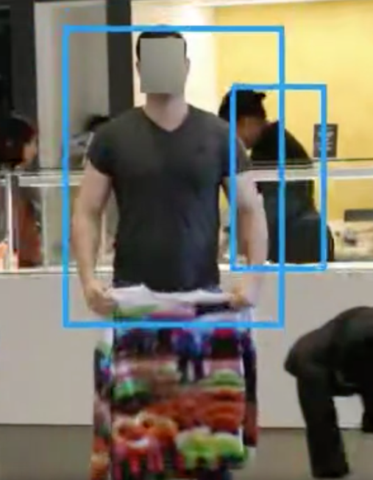
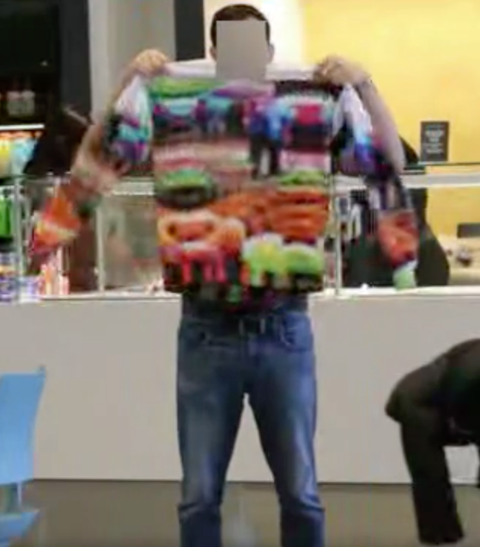

Figure 3: Wearer Moving from Visible to Invisible

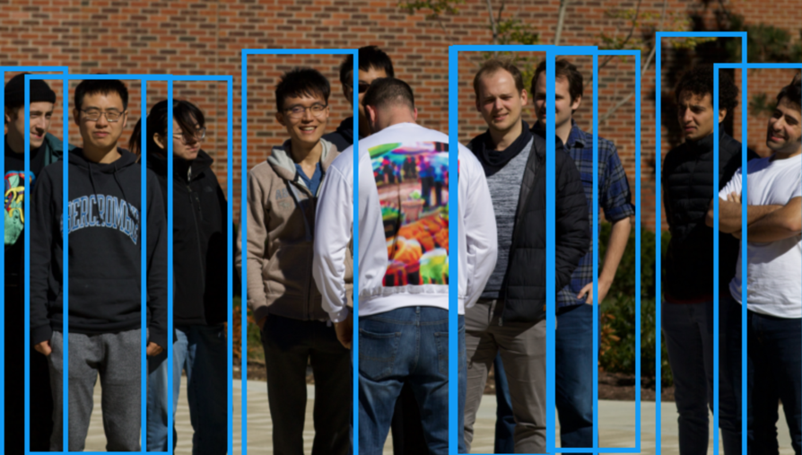

.
Figure 2: Invisibility Cloak Wearer Moving as Other are Enclosed

Furthermore, in the demo video, the wearer is seen walking around as others are enclosed and immobile in the blue, square frame of AI’s perceptibility. In this sense, the sweatshirt showcases that this kind of mobility and invisibility is a commodity, representing the privilege of being able to escape the “orbit” and “continuous network” of a controlled society (Deleuze, 6). While “How Not to Be Seen,” which dates from 2013, exemplifies the commodity of invisibility as “living in a gated community or living in a military zone” (07:30-07:39), the sweatshirt proves Deleuze’s point that control and surveillance are no longer dependant on “spaces of enclosure” (Deleuze, 1), and in this case, not even dependent on the ‘real.’ Moreover, the Invisibility Cloak is a testament to the birth of a new capitalism, one not aimed not at materiality, but at virtuality, not on products, but as Deleuze puts it “services” (6). The marketing for this sweatshirt does not seem to fully realize or acknowledge that it is selling a service, not a product. After an explanation of object detectors, the page hilariously notes that the Invisibility Cloak is a “stylish pullover,” “a great way to stay warm this winter,” with “a stay-dry microfleece lining, a modern fit” (Computer Science University of Maryland, 2020). This attempt to add on new unique selling points reads as awkward, only further amplifying that the Invisibility Cloak is not a mere product, it is a service, and that invisibility is a commodity that can be bought and worn.
In societies of control, the poles of “individual” and “mass” are no longer as relevant, the focus is placed on the “code,” “the numerical language of control” that “marks access to information, or rejects it” (Deleuze, 5). Importantly, Deleuze notes, this shift is just “as much from the point of view of integration as from that of resistance” (5), which implies that to resist, you may have to use the same tools utilized by systems of surveillance. Indeed this is what the Invisibility Cloak does; it participates in the language of code to resist it. Not only that but by offering this mode of invisibility, the cloak also turns the subject into a ghost. While the subject does not become a dividual as is the case in societies of control, they do wear the weapon; they do not embody dividuality, but instead cover themselves in it. This suggests that there might not be a way of invisibility that does not involve some kind of negotiation, either a cloaking or enclosure of one’s self, or an interaction with the system one is trying to resist.

Works Cited:
Ashton, Lucy. Rogue Pixels: The Tactics of Invisibility in Hito Steyerl’s How Not to Be Seen, 100-111. 2020.
Deleuze, Gilles. “Postscript on the Societies of Control.” October, vol. 59, 1992, pp. 3–7. JSTOR, http://www.jstor.org/stable/778828. Accessed 19 Dec. 2023.
Invisibility Cloak, Computer Science University of Maryland, 2020, www.cs.umd.edu/~tomg/projects/invisible/.
Steyerel, Hito, and Paglen, Trevor. I Will Survive, Films and Installations, “The Autonomy of Images.” pp. 221. Centre Pompidou, https://www.kunstsammlung.de/press/Hito_Steyerl_I_Will_Survive_A_Digital_min.pdf, 2020.
Steyrel, Hito. “How Not to Be Seen: A Fucking Didactic Educational .MOV File.” YouTube, 14 Sept. 2013, www.youtube.com/watch?v=LE3RlrVEyuo.

Table of Figures:

Figure 1: Invisibility Cloak with Adversarial Pattern 2
Figure 3: Wearer Moving from Visible to Invisible 3
Figure 2: Invisibility Cloak Wearer Moving as Other are Enclosed 4

